Atria Institute of Technology



**Department of Information Science and Engineering**

**Big Data Analytics (18CS72)**

**Assignment-1**

**SUBMITTED BY**

Name: VIDYA J

USN:1AT20IS103

Section: B

Submission Date: 27-11-2023

**COURSE HANDLING FACULTY NAME:**

Dr. K S Ananda Kumar

Associate Professor

Dept of ISE, Atria IT.

**Table of contents**

|  |  |
| --- | --- |
| **Sl. No** | **Description** |
| 1 | 1. create an **EC2 Linux** instance in AWS Cloud /Any cloud  INSTANCE NAME – Vidya j  INSTANCE TYPE – t2.micro/any other also.  key pair name- vidya-linux  storage - 10 GB  Take the screenshot of instance running status  Mention the private IP address and Public IP address.  (Execute this program/concept and take a screenshot of the output) |
| 2 | Execute the basic Linux commands/ simple program on the instance  (Execute this program and take a screenshot of the output) |
| 3 | Create the **GitHub** Account with your credentials, Same things stored in public repository in Github. Share the assignment in github link. |

**Instance Creation-01**

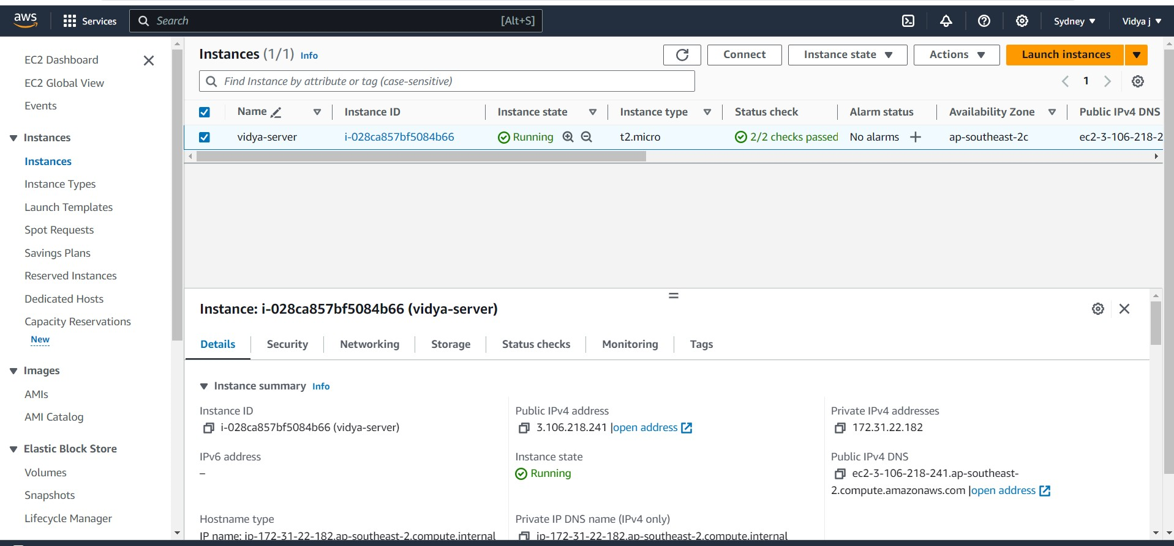 SCREENSHOTS OF AWS INSTANCE

* Instance:

i-028ca857bf5084b66 (vidya (Linux server))

* Instance ID:

i-028ca857bf5084b66 (vidya (Linux server))

* Public IPv4 address:

3.106.218.241

* Private IPv4 addresses:

3.106.218.241

* Instance state:

Running

SCREENSHOTS OF AWS INSTANCE

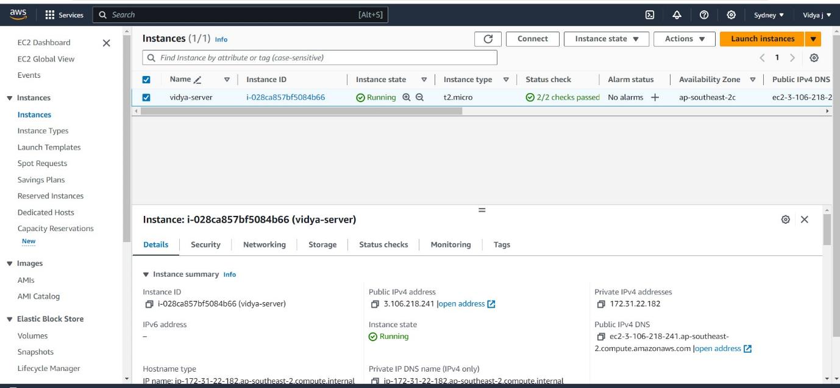

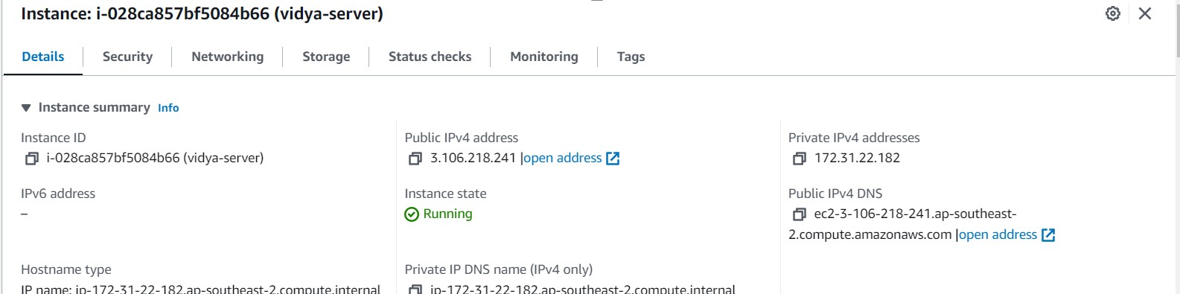

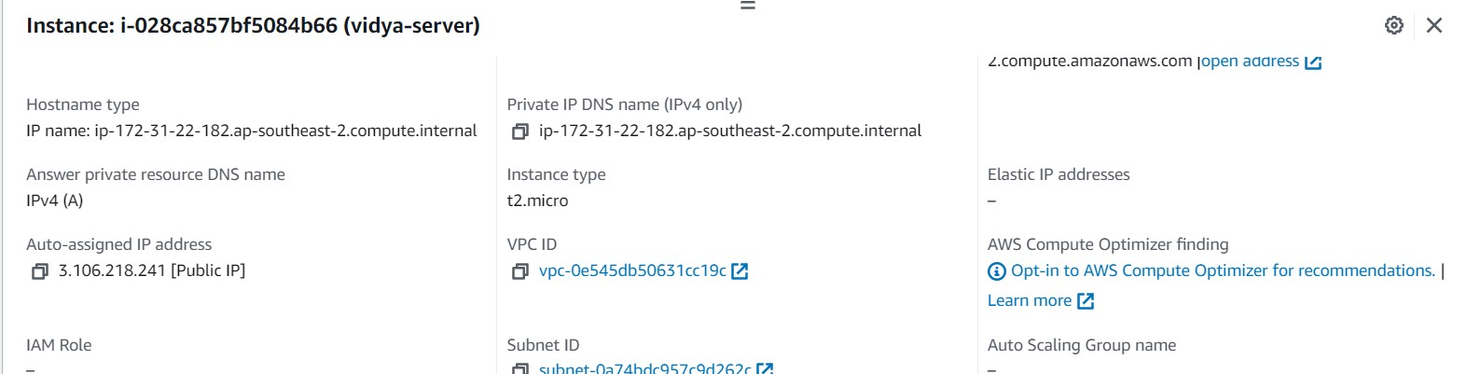

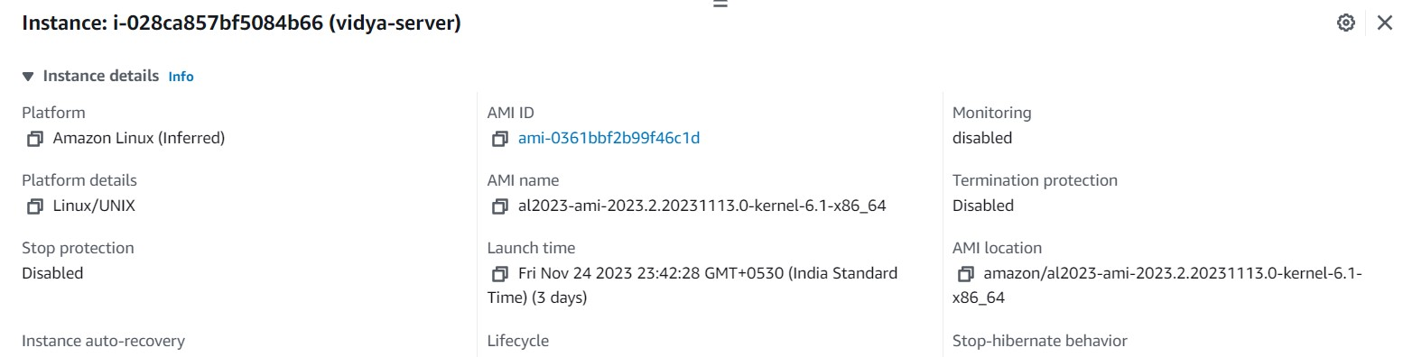

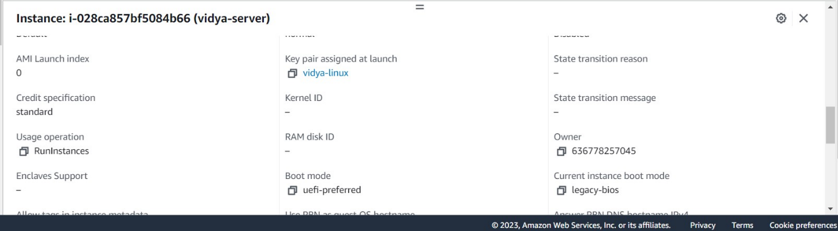

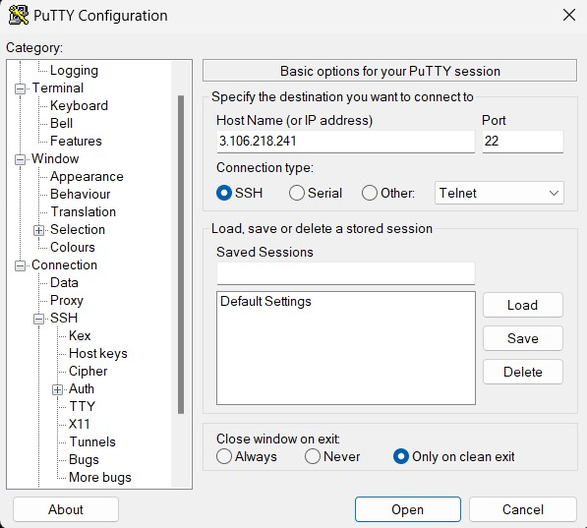SCREENSHOTS FROM puTTY-Setup

In putty under host name enter the Public IPv4 address.

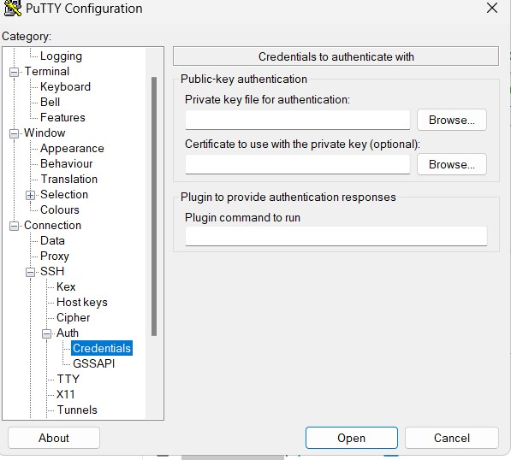

Under Auth in private key file for authentication browse and add the PuTTY Private Key File (.ppk) named vidya j-linux.

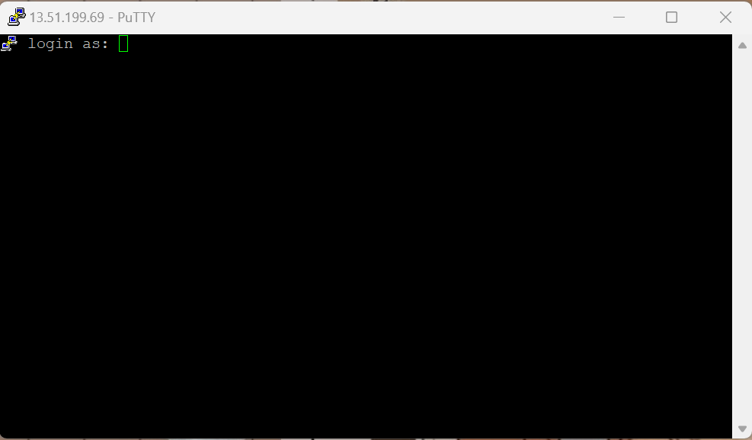After browsing click on Open button

This directs us to this screen now enter the User name that is ec2-user

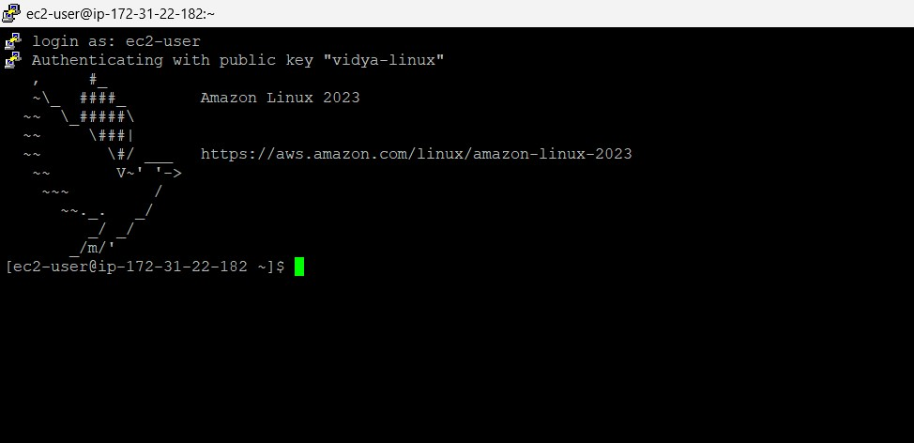

Ater successful login it authenticates and now we can enter any commands.

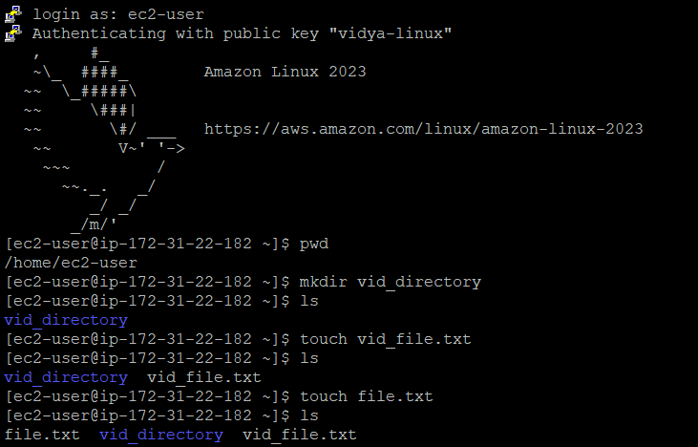 SCREENSHOTS FROM puTTY-commands

* pwd:

pwd is used to present working directory, this gave the output /home/ec2-user

* mkdir:

The mkdir (**m**a**k**e **dir**ectory) command creates a new directory in the provided location. I have created a directory called new_directory .

* ls:

The ls command (**l**i**s**t) prints a list of the current directory's contents. Therefore we got the directory created display as output.

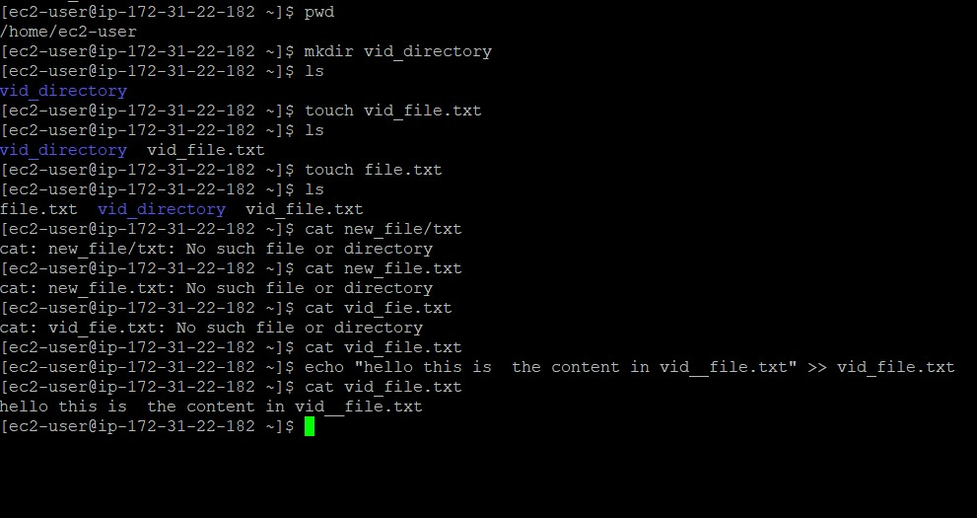

* touch:
* The touch command's primary purpose is to modify an existing file's timestamp. The command creates an empty file if it does not exist. Due to this effect, touch is also a quick way to make a new file (or a batch of files).
* Here I have created a txt file called vib_file first then a second txt file called file_txt.
* Using ls command we can find where these files have been created .
* cat:
* The cat command (con**cat**enate) displays the contents of a file in the terminal (standard output or stdout).
* To use the command, provide a file name from the current directory.
* Here I provide the txt file called new_file.txt.
* echo:
* The echo command to print arguments to the terminal.
* Here I have used echo “hello this is the content in vib_file.txt”.
* The >> operator redirects output to a file.

Later I use cat to find the content in vib_file.txt. Therefore we can see that “hello this is the content in vib_file.txt” has been added to new_file.txt



cat file.txt is executed to show that there is no content in file.txt.

* cp:
* The main way to copy files and directories in Linux is through the cp (**c**o**p**y) command. cp <source file> <target file>.
* The source and target files must have different names since the command copies in the same directory. Provide a path before the file name to copy to another location.
* Here we are copying the content of vib_file.txt into file.txt using cp [cp vib_file.txt file.txt]
* Then when we use cat on file.txt it shows “hello this is the content in vib_file.txt” so content is successfully copied.
* Now we make use of echo and >> to add a new line in file.txt i.e “after copying contents from vid_file I am adding a new line into file.txt”.
* Now when cat is used on file.txt both are lines are given as output.

**Assignment GitHub Link:**